# Information Visualization

# CHECKPOINT III: Visualization Sketch

G31-A

**1. Overview**

The visualization we designed is made up of five different idioms, allowing the user to explore the data related to aircraft crashes in different ways.

On top of the visualization there is a filter selection area, allowing the user to filter all the diagrams in the visualization. The user can choose to see individual crash causes, countries or aircraft manufacturers, and for each of these, they can choose to omit or show individual causes, countries or manufacturers, allowing easy comparisons. Each of the selected filters will be assigned a colour that is consistent in all of the diagrams.

The first idiom is a 3D globe showing the supposed routes of the aircrafts that crashed, and the specific point where the crash occurred. This allow the user to see not only the spatial distribution of the crashes, but also to get information on a specific crash by hovering the crash and examining the popover.

Then we have a line chart that can show the evolution of the casualties of crashes over the years. For each of the selected filters, the user can choose to show or hide the lines corresponding to the number of carried passengers, the number of passengers that died in crashes and the death ratio.

Following this, we have a Sankey diagram allowing the user to examine the relationships between the passengers who died and survived not for each of the different filters, but also how the number of passengers travelling evolved over the years. This diagram includes a granularity filter allowing the user to see individual years or group them into decades or other groups of years.

We also have a word cloud that allows the user to quickly see the most used words in the crash narratives. This visualization should be updated according to the selected filters. By hovering a word the user is able to see the exact number of occurrences of that word.

Finally, there is a line chart showing an overview of the total number of crashes over the years, which also allows the user to select a time span to filter all the above diagrams. By hovering this graph, the user can see the exact number of crashes for that year.

**2. Visual Encoding**

The diagrams we chose encode the following information:

* 3D Globe
  + **Departure and arrival locations** are given by the extremities of the lines.
  + **Crash locations** are given by pins on the globe.
  + **The number of deaths** is given by the height of the pin.
  + **The number of passengers** is given by the line width.
  + **The filter this crash relates to** is given by the hue of the line and pin.
  + **The position along the route from departure to arrival** is given by a gradient of lightness in the lines.
* Line Chart
  + **The selected measure (Carried, Fatalities, Ratio)** is given by the line type (continuous, dashed or dotted).
  + **The related filter** is given by the line colour.
  + **The number of passengers** is given by the height in relation to the left axis.
  + **The percentage of dead passengers** is given by the height in relation to the right axis.
  + **The years** are given by the bottom axis.
* Sankey Diagram
  + **The amount of passengers involved in crashes for each year/decade/…** is given by the height of the bars on the left.
  + **The amount of passengers involved in crashes of a given filter** is given by the height of the bars in the middle.
  + **The corresponding filter** is given by the colour of the bars in the middle.
  + **The total number of dead passengers and survivors** is given by the height of the bars on the right.
  + **The common passengers between bars** are given by the flow from one column of bars to the next.
* Word Cloud
  + **The number of occurrences of a word** is given by its size.
* Global Timeline
  + **The number of crashes** is given by the height of the line.
  + **The corresponding year** is given by the position on the horizontal axis.

**3. Idiom and Tasks/Questions**

* + - 1. **3D Globe**

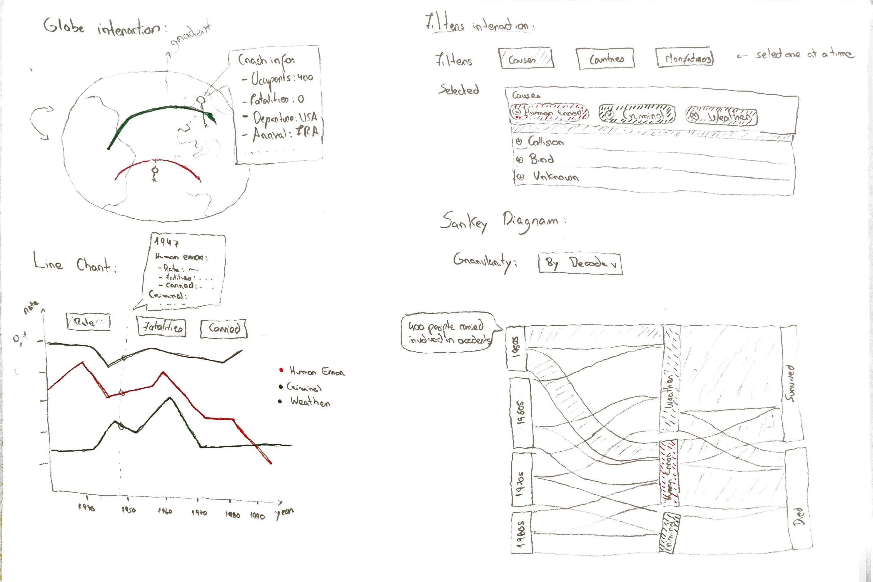

* + - 1. **Locate the geographical zones where more accidents occur** by analysing the density of pins in different areas of the globe.
      2. **Compare the crashes in different geographical zones** by analysing the colours, heights and lines in different areas of the globe.

**Line Chart**

**Explore the evolution of carried passengers over the years** by selecting the “Carried” option and analysing the progression of the line over the years.

**Compare the volume of passengers carried with the number of fatalities, per year,** by selecting both the “Carried” and the “Fatalities” options and comparing the continuous and dashed lines over the years.

**Identify the most probable causes for accidents** by selecting the causes filter and identifying the highest line in graph.

**Sankey Diagram**

**Compare the number of passengers involved in accidents with an aircraft of a given manufacturer** by selecting the Manufacturer filters and comparing the heights of the bars in the middle column.

**Explore the relationships in passenger involvement in crashes for different years, countries and their survivability** by selecting the Countries filters and analysing the flow between the columns in the graph.

**Word Cloud**

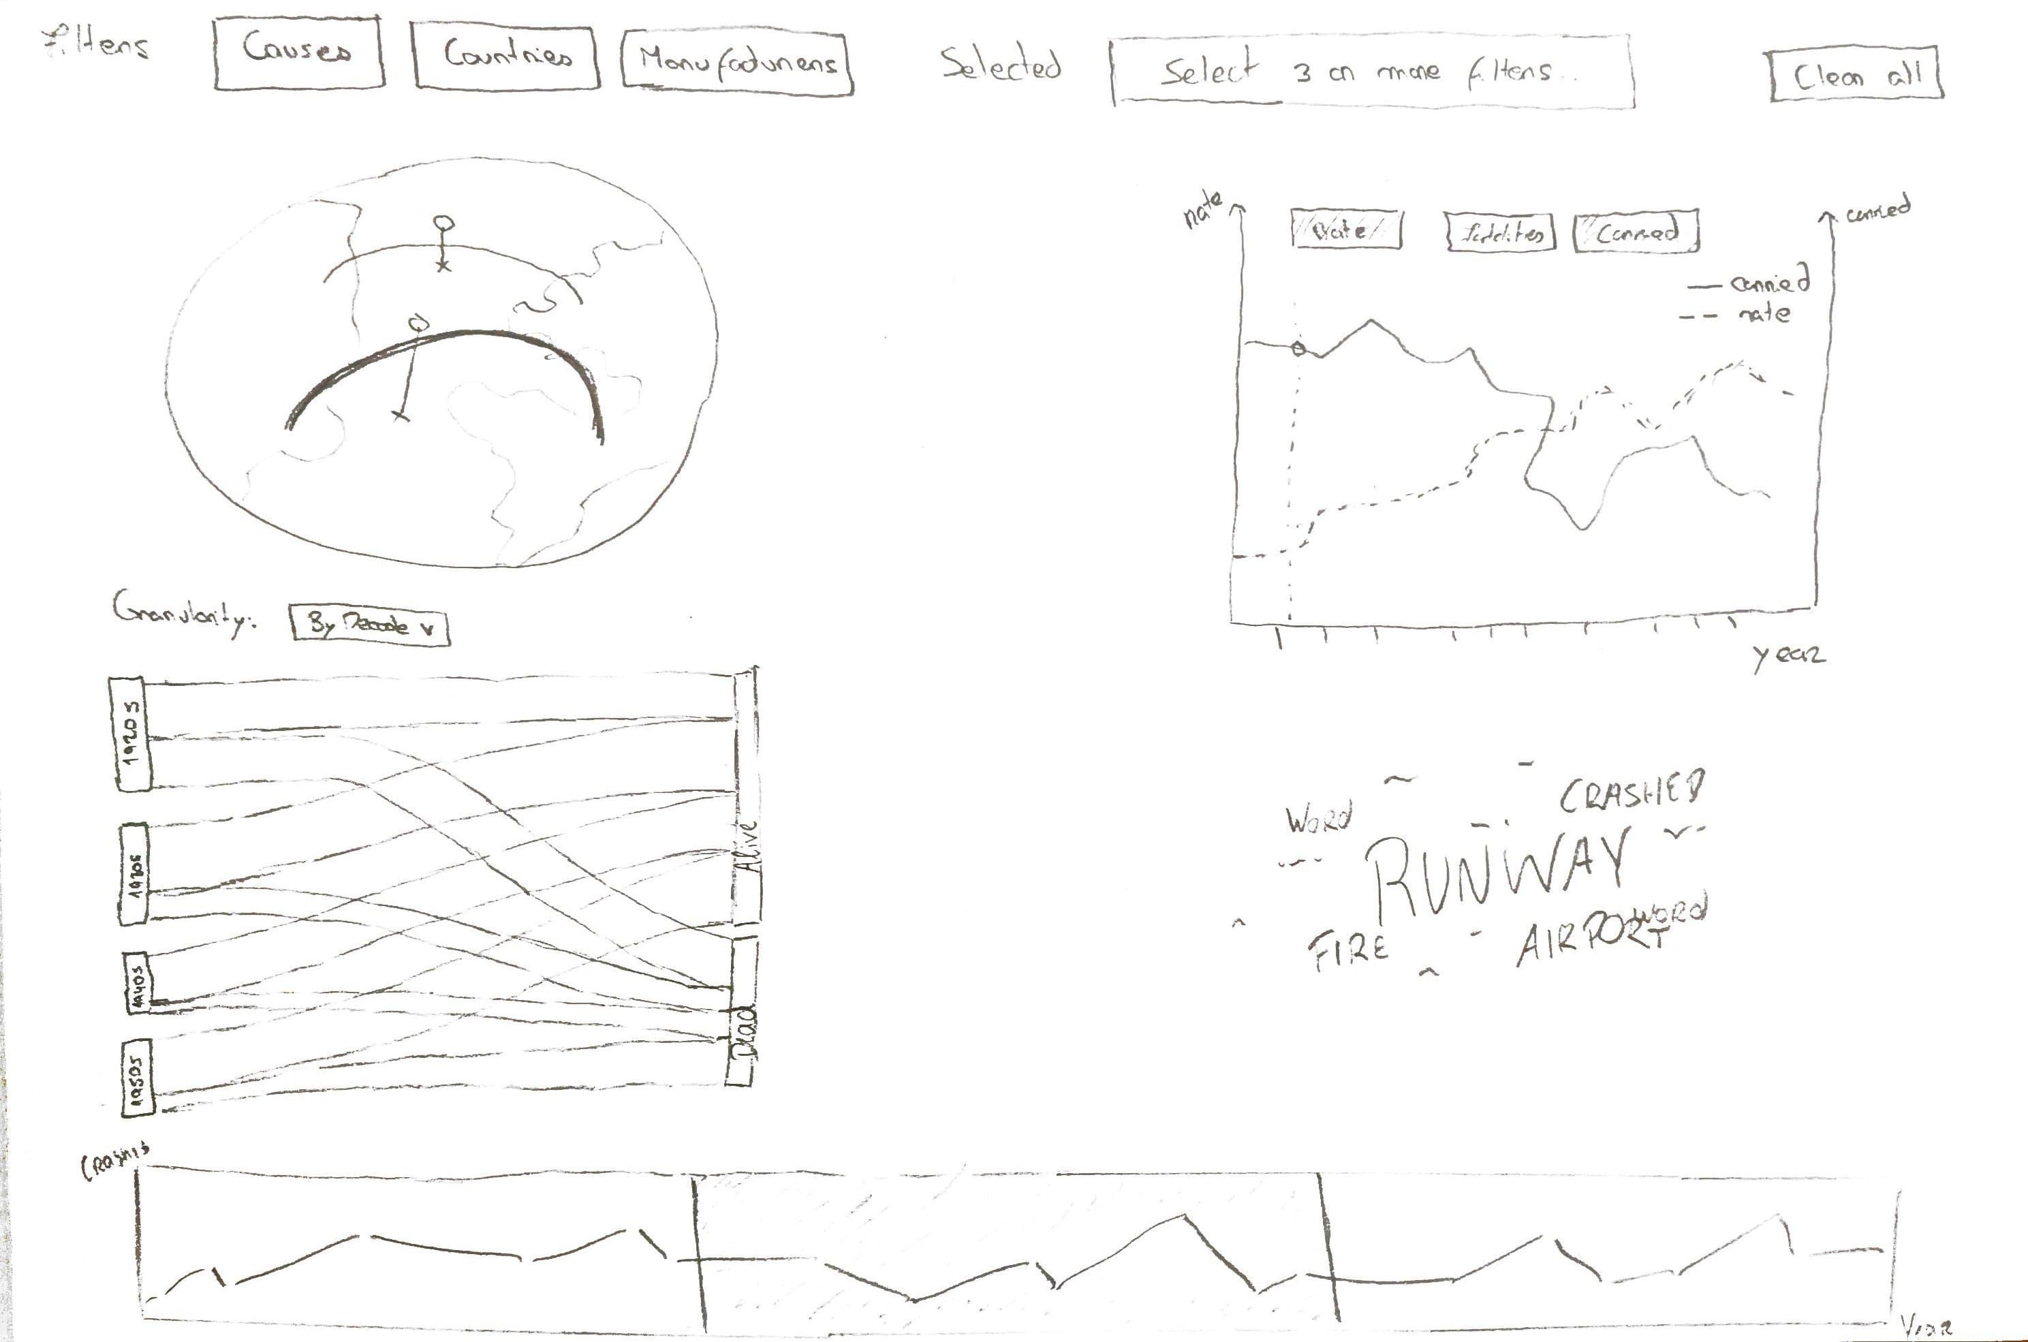

**Identify the most common words used in accident narratives** by comparing the sizes of different words in the cloud and locating the largest ones.

**Global Timeline**

**Explore the evolution of aircraft accidents over the years** by analysing the progression of the line height over the years and identifying trends.

